JAVA ASSIGNMENT

**Submitted by,**

Tamilvanan B.

2018503566.

MO Batch.

09-02-2020.

**Write a Java program that accepts a string and encrypts it using the logic. The program should contain the following features**

1. **Overloaded constructors**
2. **Constructor chaining**
3. **Copy constructors**

Program:

import java.util.Scanner;

class Encryp{

int len;

String string;

Encryp(){

this("HAI",3); // for chaining purpose.

}

Encryp(String str, int length){

string = str;

len = length;

}

Encryp(Encryp str){ // copy constructor

System.out.println(" ");

for(int i=0;i<str.len;i++){

char chr = str.string.charAt(i);

int z = (int) chr; z %= 10;

switch (z){

case 1:

System.out.print('A');

break;

case 2:

System.out.print('B');

break;

case 3:

System.out.print('C');

break;

case 4:

System.out.print('D');

break;

case 5:

System.out.print('E');

break;

case 6:

System.out.print('F');

break;

case 7:

System.out.print('G');

break;

case 8:

System.out.print('H');

break;

case 9:

System.out.print('I');

break;

case 0:

System.out.print('Z');

break;

}

}

System.out.println(" ");

}

}

public class Encryption{

private static boolean isUp(String ip){

for(int i=0;i<ip.length();i++){

if(!Character.isUpperCase(ip.charAt(i))){

return false;

}

}

return true;

}

public static void main(String... args){

Scanner sc = new Scanner(System.in);

String ip;

while(true){

System.out.print("\nEnter the text: ");

ip = sc.next();

if (isUp(ip)){

Encryp obj1 = new Encryp(ip,ip.length());

Encryp obj2 = new Encryp(obj1);

break;

}

else{

System.out.println("\nEnter uppercase string...");

}

}

}

}

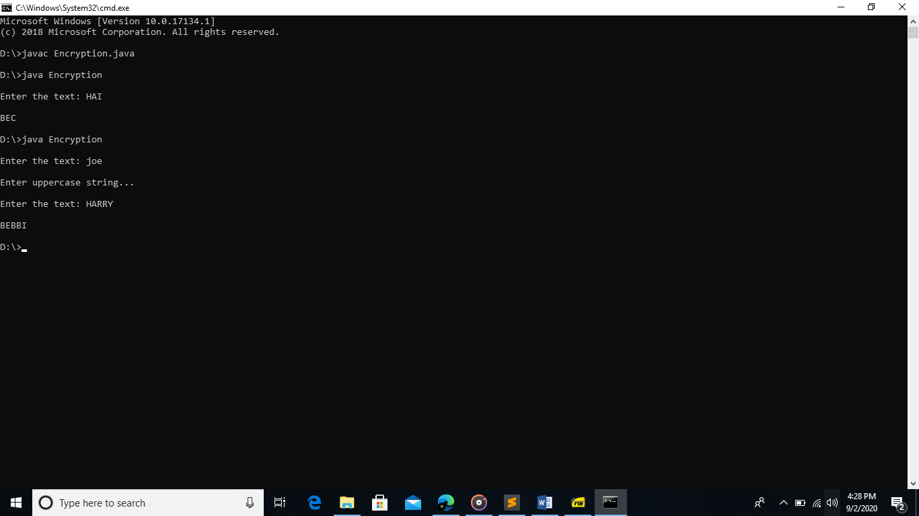OUTPUT: